**Albany Wellness Center – Visual Tour**

**The Albany Wellness Center is conveniently located on the Russell Sage College campus at 140 New Scotland Ave., Albany, NY 12208, in the Kahl Campus Center, Lower Level. This location is less than a 15-minute walk from anywhere on the ACPHS Campus. For commuter students, there is ample parking in the lot off of Academy and Helderberg Roads.**

**Kahl Campus Center**

**Kahl Campus Center Door Near Parking Lot**

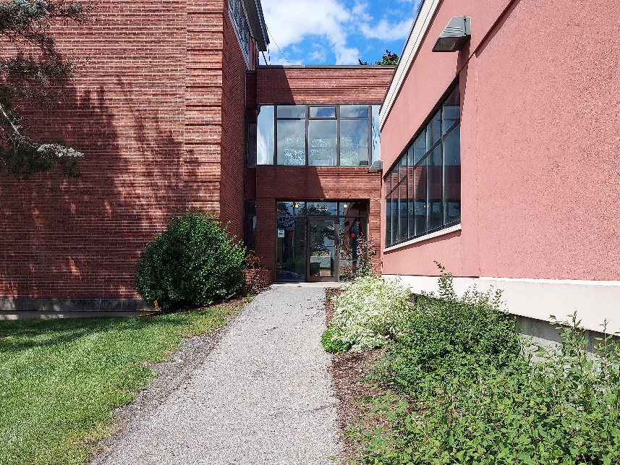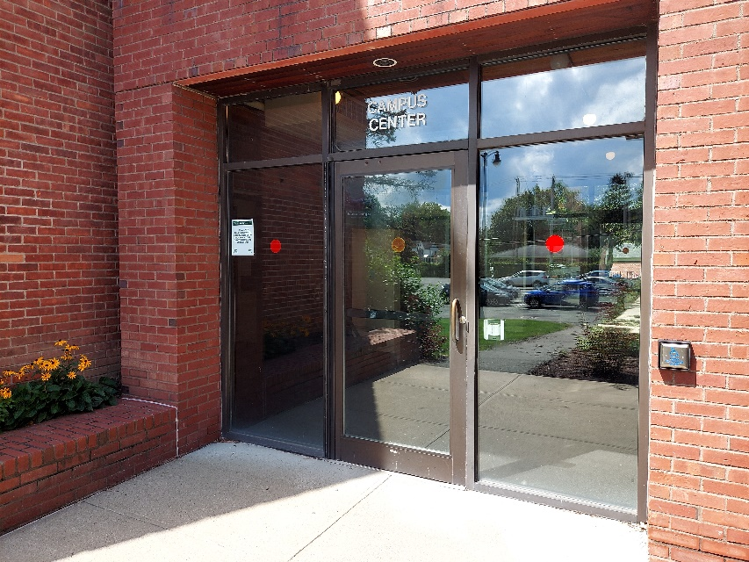

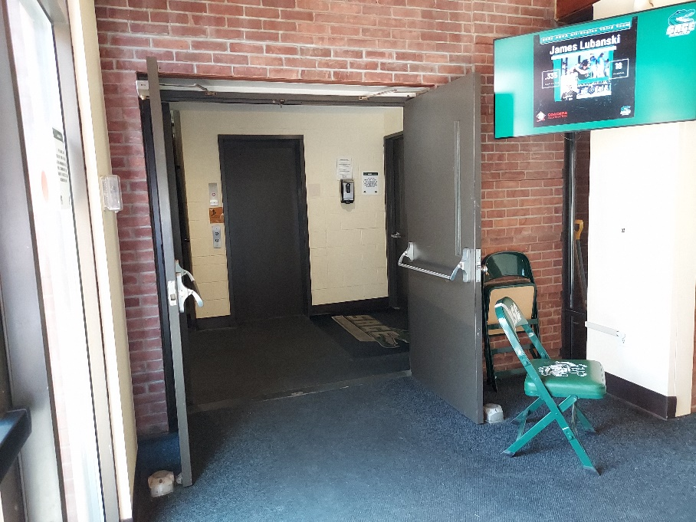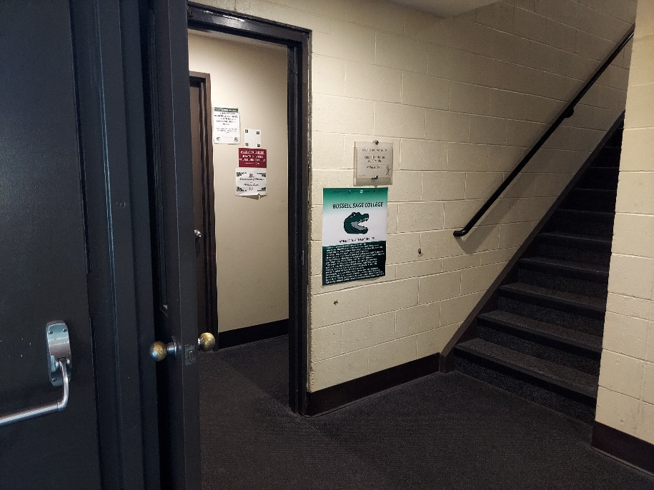

**Go to the Left After Entering the Building**

**Take Another Left through the Door next to the Stairs**

**Go Down the Stairs and Take a Right**

**(A Wellness Center maroon sign should be**

**on your left side at the top of the stairs)**

**Go Through the Door with the**

**“Lower Level Offices” Sign**

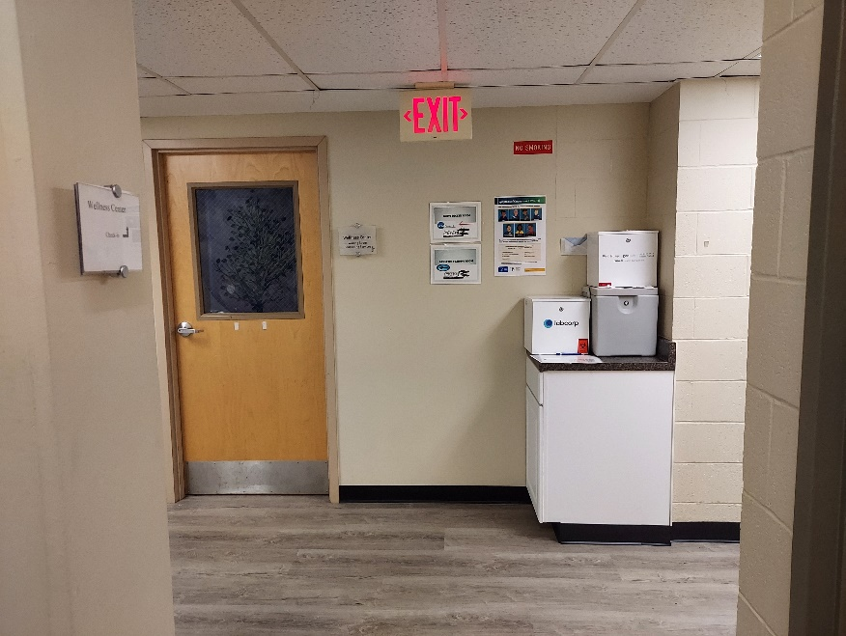

**At the End of the Hall, Turn Left**

**Walk Down the Entire Hall**

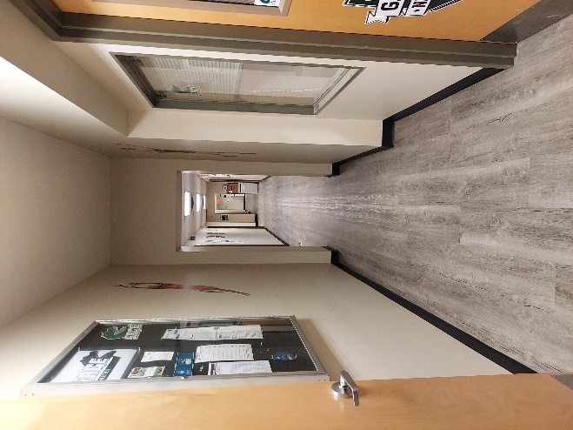

**Off the Reception Area is a**

**Separate Waiting Room**

**Through the Glass Doors is the**

**Albany Wellness Center Reception and Lobby Area**

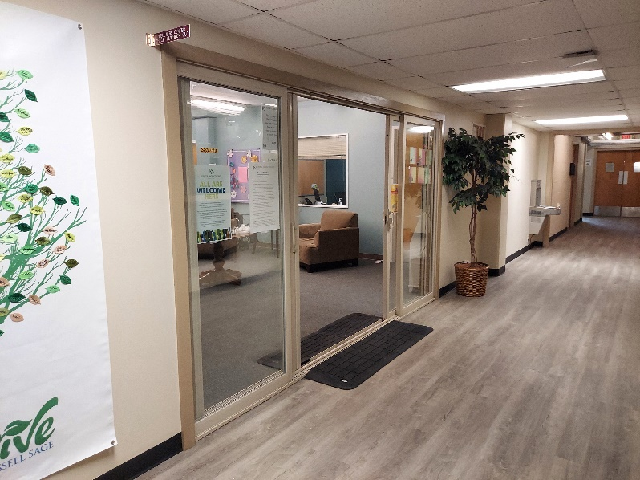

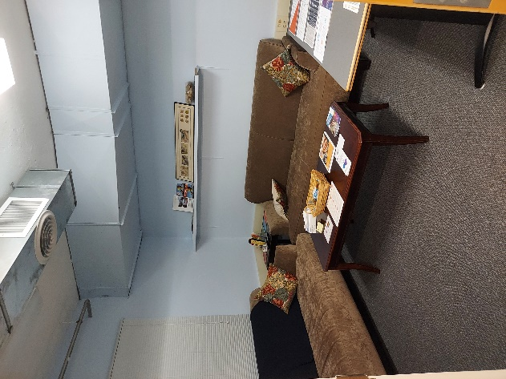

**Examination Room**

**Examination Room**

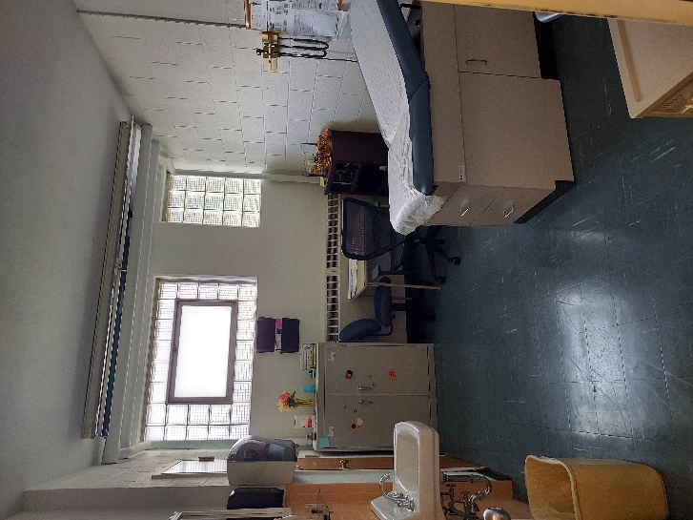

**Examination Room**

